How do I become Fossilized? (Grades 5-12)

Tennessee State Standards Covered
CLE 3210.5.1 Density of bone in relation to preservation
CLE 3204.4.6 Relate fossilization with environment and preservation method
CLE3295.2.5 Develop an awareness of the limitations to scientific investigations.
GLE 0607.2.3 Relate fossilization with abiotic and biotic components of the environment
GLE 0807.5.4 Variation and Fossil preservation
GLE 0607, 0707, 0807. Inq 3 Cause and effect in fossil preservation

Overview
Describe how a human body is likely to decay in different environments; describe and explain environments in which bodies are less likely to decay and therefore more likely to fossilize.

Underlying Principals
- Bodies undergo a series of decay processes after death in which material is progressively lost
- Most organisms, even those with hard parts, are never fossilized
- The environment in which something dies or is buried is crucial to its fossilization potential
- To be classified as a true fossil, the organism must have been preserved for at least 10,000 years. Many well-preserved human remains (e.g. Tolland Man) are more recent than this to illustrate the principals of fossilization.
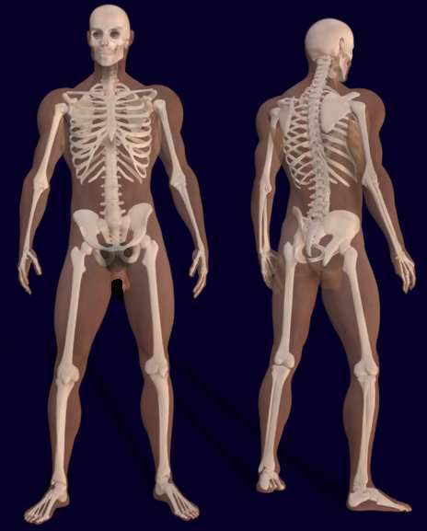
Figure 1: A body with its skeleton. This file This file is licensed under the Creative Commons Attribution 3.0, Author Bernhard Ungerer.

Learning Outcomes
- Describe how a human body is likely to decay in an active river/marine environments
- Describe and explain environments in which bodies are less likely to decay and so in which fossilization is more likely

Context
Students think through the decay processes that the human boxy is likely to be involved in as it moves towards fossilization – as a means of gaining understanding of fossilization processes and what fossils are.

Thinking Skills Development
Students are asked to use their thinking skills to imagine how a body might decay – “bridging” between the characteristics of a living body and how it might behave after death.

ACTIVITY: HOW DO I BECOME FOSSILIZED?
Material
- One enthusiastic volunteer

Procedure
Ask a visitor or a member of your class to stand where everyone can see them and ask: what would happen if [volunteer] fell into a nearby river or the sea and died-how might they become fossilized?
Lead them through this story:
- The current drags the body along the bottom, scratching the skin so that blood runs into the water
- Creatures start eating at the scratches and at other, softer parts of the body like eyes.
- Small water creatures enter through any holes and start eating from the inside
- After a few days, decay of food in the stomach produces gas so that the body floats to the surface and is carried along
- Fish and other creatures attach any weak points, gradually begin to remove the skin
- When the skin and other soft parts, like the guts and lungs, have been removed, the body sinks to the bottom again and the muscles start to rot.
- As the muscles rot and are eaten, most bones are still held together by ligaments, but these begin to decay, so that small bones begin to separate
- Currents roll or drag down the bones along the bottom grinding them down and breaking them up-first the smaller ones and then the larger ones
- Eventually, all that is left is the hardest parts of the body: the teeth
- These too are rolled around, worn down, and broken up, so that nothing is left.
- This is what happens to perhaps 99.9% of dead creatures-they are eaten, broken up, and are not fossilized.

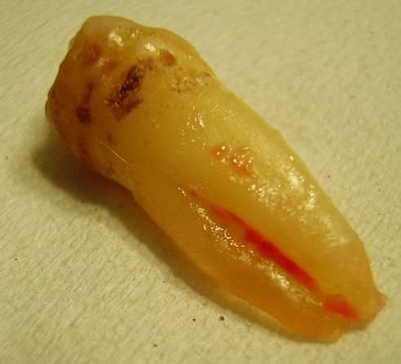
If I do want to become fossilized, what should I do?
A tooth – usually the last part of a human to be left and so the part most often fossilized; © Werneuchen
Ask the class this question, and steer them towards answers like these.
The best chances of fossilization are:
- When there is absolutely no activity to drag bodies along
- Where there is no oxygen, so that animals might eat the body can’t live there
- Where there is no oxygen so that the bacteria that might rot the body can’t live there either
The best chance of getting these conditions is if the body is buried. So, if you want to be fossilized, don’t fall into a river or sea, but asked to be buried!

Burial is better in some areas than others, however. If you are buried in the ground that water can flow through, like sand, the water will bring oxygen and bacteria will decay and break up the body. You will need to be buried in impermeable ground-like mud or clay that will keep water and oxygen out, like this man (below) who died over 6,000 years ago and buried in a bog! Not only were his bones preserved, but his skin and clothes were too!

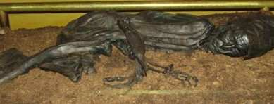
4th century B.C. Tollund Man preserved in a peat bog in Denmark

If I don’t want to become fossilized, what should I do?
Places where you are not likely to be fossilized include:
- Areas with lots of physical activity, like mountaintops, fast flowing rivers, beaches, roads, etc.
- Areas with lots of oxygen (like above Earth’s surface)

